Name : Sowmiya K

Reg no : 73152115071

Email id : ceecsowmiya2025@gmail.com

**SQL DAY -1 LAB**

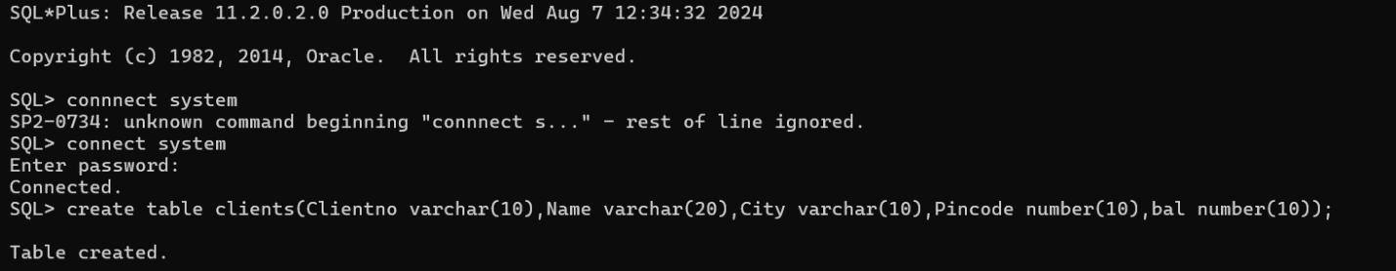

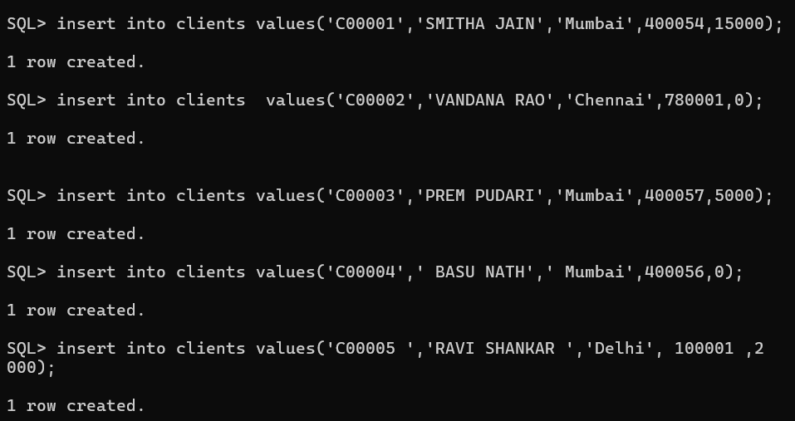

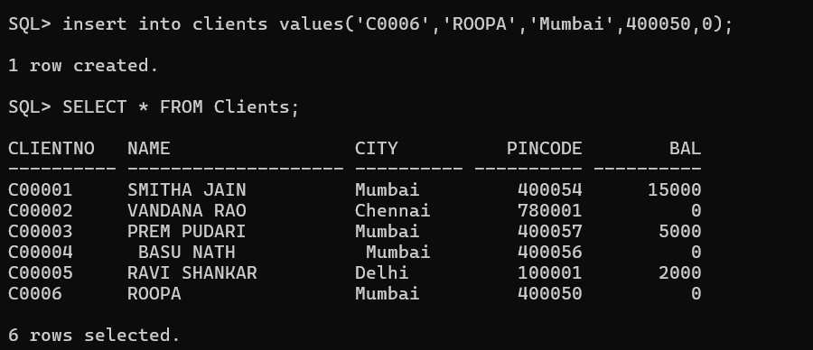





**List all details from the client_master table for clients whose Bal_due = 0.**

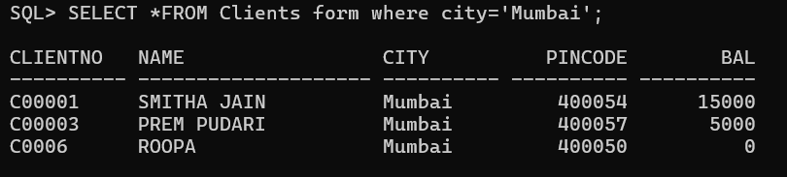

**Update table client_master, Change city of Client_no C00004 to Jaipur.**

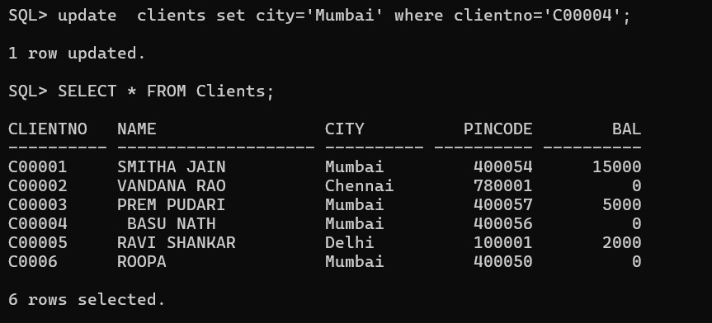

**Retrieve records of clients residing in Mumbai.**

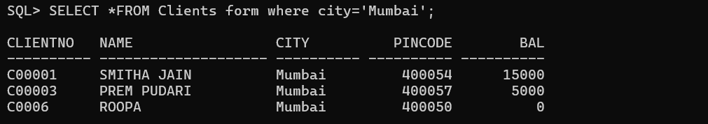

**Construct English like sentence from the table client_master ({Customer name} live in the city of**

**{city}).**

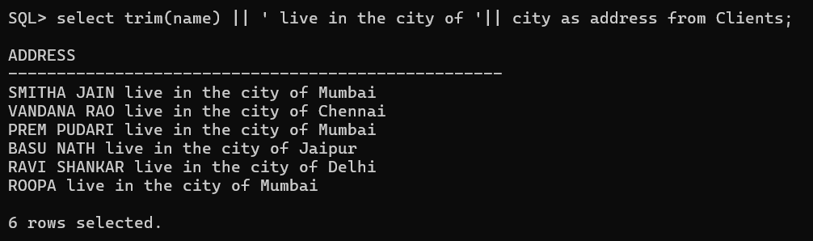

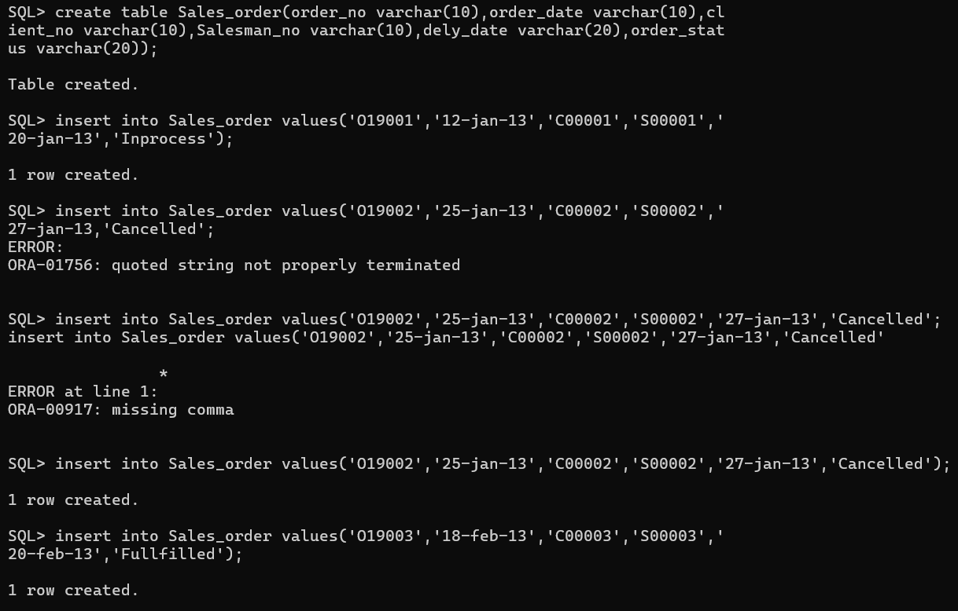

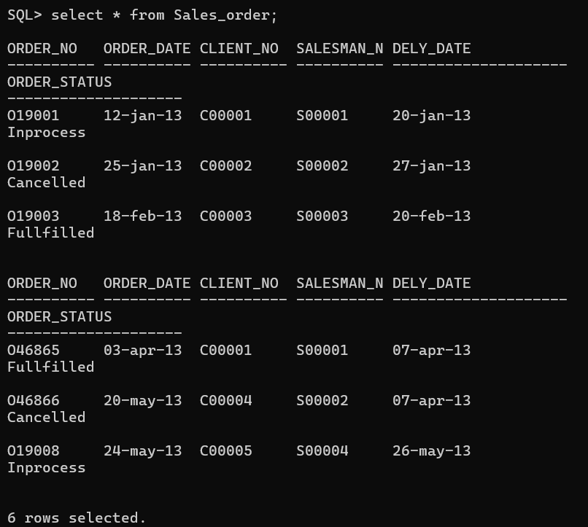

**List the client_no, name, city and pincode of clients whose Order_status is "In process".**

